Option Strategies

**Options as Insurance**

# Graphing Payoffs

* For a portfolio involving one or more assets, the payoff diagrams can be complicated to visualize off the top of your head
* Assuming that all options have the **Same Underlying & Expiration Date**, we can use a **Payoff Table** to **easily account for all possible payoffs**
  + Each **Row** of the table represents a **unique asset**
  + 
  + Each **Cell** of the table contains the **payoff** of the asset at that particular strike price boundary - the payoff should reflect the **total number of contracts as well**
* **Aggregate** all the cashflows in each column to obtain the **payoff for the portfolio**
  + **Constant Values** represent **Horizontal** lines
  + 
  + 
* Remember that the table values and resulting graphs are **just Payoffs** - need to account for the initial cashflow to obtain Profit

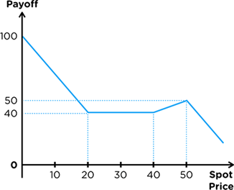

# Options as Insurance

* **Calls guarantee a purchase price** thus protects against **Upside Risk (Risk of Price Increase)**
* **Puts guarantee a selling price** thus protects against **Downside Risk (Risk of Price Decrease)**
* **Option Holders** pay premium to the Option Writer for them to bear the above risk (Insurance)

# Buying Insurance (Long Option Positions)

* **Long Position** in the Underlying
  + Intention to sell in the future → Downside Risk
  + Protect Long Positions with Puts
  + Known as a **Floor Strategy** as it sets a floor (**lower limit**) on the selling price
  + **Minimum Gain** on Long - Floor
* **Short Position** in the Underlying
  + Intention to buy in the future → Upside Risk
  + Protect Short Positions with Calls
  + Known as a **Cap Strategy** as it sets a Cap (**upper limit**) on the buying price
  + **Maximum Loss** on Short - Cap
* Resulting Portfolios are also known as **Protective Options** as they **protect the underlying**

## Floors (Protective Put)

K < ST 
Long Underlying 
Long Put 
Overall Cashflow 
K —ST 

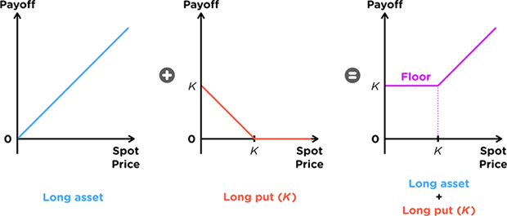

## Caps (Protective Call)

ST < K 
-ST 
Short Underlying 
Long Call 
Total Cashflow 
K < ST 
-ST 
Sr —K 
-K 

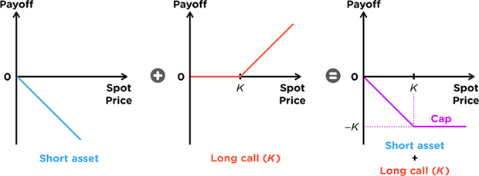

# Selling Insurance (Short Option Positions)

* For every option bought, there **must be someone to write the option**
* There are **two ways to write** options:
  + **Naked Options** → **Without an existing position** in the underlying
  + **Covered Options** → **With an existing position** in the underlying
* Covered Positions are preferred as they help to **offset the risk borne** by the Option Writer
  + They are direct opposites to Floors & Caps - reflections about the Axis
* They are known as Covered Positions as the option is **covered by the underlying**

## Covered Calls

Long Underlying 
Short Call 
Overall Cashflow 
Sr < K 
Sr 
ST 
K < ST 
K —ST 

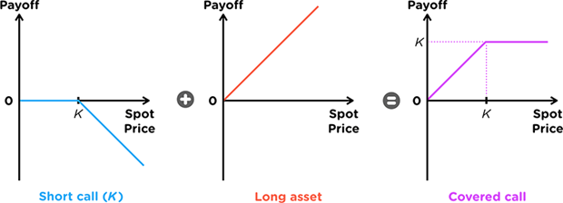

## Covered Puts

Short Underlying 
Short Put 
Total Cashflow 
-ST 
Sr—K 
-K 
-sr 

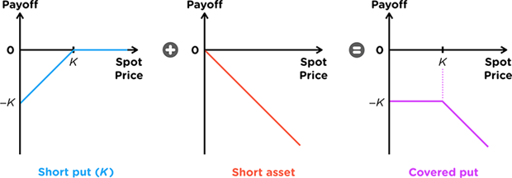

**Spreads (Long Only)**

# Option Strategies

* Spreads are strategies that contain **ONLY** one kind of Calls or Puts
* Combinations are strategies that contain **BOTH** kinds of Calls and Puts

# Bull Spreads

* 
* It has the added benefit of Insurance - **limiting losses** if the price does not rise high enough with the downside of **limiting gains** if it rises too much
* Bull Spreads can be formed by **Buying a lower strike** Call/Put & **Selling a higher strike** Call/Put

## Call Bull Spread (Long)

* 
* 

Long Call at Kl 
Short call at K2 
Total Cashflow 
o 
-CST - K2) 

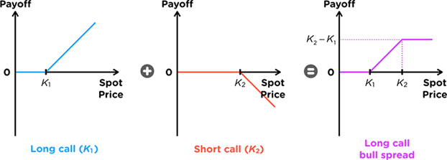

## Put Bull Spread (Short)

* 
* 

S < Kl 
Long Put at K 1 
Short Put at K2 
= Sr—K 
Total Cashflow 
K2<S 

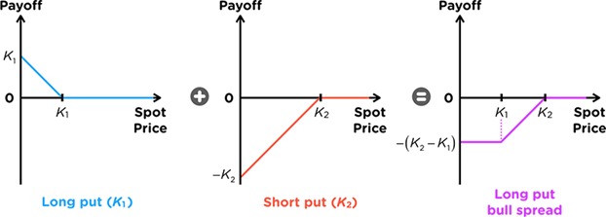

# Bear Spread

* 
* It has the added benefit of insurance - limiting losses if the price does not fall low enough with the downside of limiting gains if it falls too much
* Bear Spreads can be formed by **Selling a lower strike** Call/Put & **Buying a higher strike** Call/Put
* It is the OPPOSITE of a Bull Spread - Reflection about the X-axis

## Call Bear Spread (Short)

* 
* 

Short Call at K 1 
Long Call at 
Total Cashflow 
o 
—CST — Kl) 
—CST — RI) 

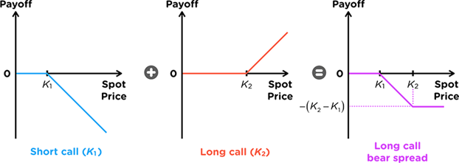

## Put Bull Spread (Long)

* 
* 

S < Kl Kl < S<K2 
Kz<S 
Short put at Kl 
Long Put at K2 
Total Cashflow 

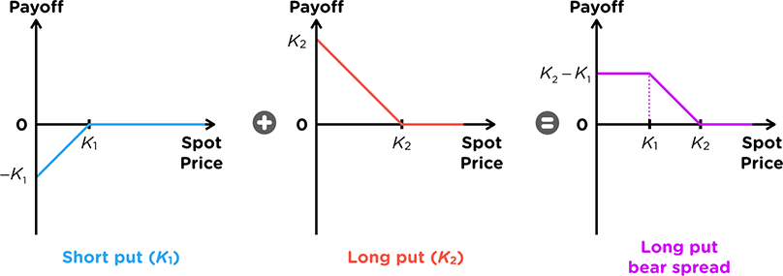

# Box Spread

* Box Spreads have a **Constant Horizontal Payoff**- the resulting shape of the entire graph looks like a Box, hence it is known as a **Box Spread**
* The payoff is identical to that of a Zero Coupon Bond, thus Box Spreads are used as an alternative method to borrow or lend money
* Box Spreads can be formed by forming with a Bull Spread with Calls and an otherwise identical Bear Spread with Puts
  + It is *technically* not a spread because it uses both Calls and Puts - but it is often referred to as a spread because it uses two Spreads

## Call & Put Box Spread

* 
* **Net cash outflow at time 0** as both underlying spreads have a cash outflow
* Thus, this Box Spread is akin to **buying a Zero-Coupon Bond**

S<KI 
Call Bull Spread 
ST -K 
Put Bear Spread 
Total Cashflow 

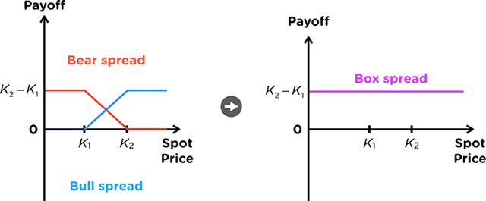

# Butterfly Spread

* 
  + It is known as a Butterfly as the payoff diagram resembles a Butterfly
* It has the added benefit of insurance - limiting losses if the price changes more than the boundary with the downside of limiting gains when the price does not move at all
* Butterfly Spreads can be formed by:
  + Buying a Bull Spread and Selling a Bear Spread (All Calls)
  + Selling a Bull Spread and Buying a Bear Spread (All Puts)
* **Buying and Selling** the butterfly is **dependent on the strikes** used for each spread
  + Recall the **Strike Price Condition** for both Calls and Puts
  + If the Long Position on either combination has the higher cost, then the overall Butterfly formed will be a Long position
  + 
  + 
* There are two kinds of Butterfly Spreads:
  + 
  + 

## 

## Call Butterfly Spread

* 
* **Net Cash Outflow** at time 0

κι < s 
Call ΒΙΙΙΙ Spread 
(Κι,Κ2) 
Call Bear Spread 
(K2,K3) 
Total Cashf10w 
κα —κι 
K2—sr 
-κι +21<2 -ςτ 
K3<S 
κι —κι 
Κ2—κ, 

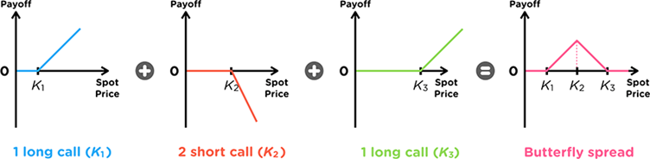

### 

## Put Butterfly Spread

* 
* **Net Cash Outflow** at time 0

Put Bull Spread 
Kt—K2 
put Bear Spread 
Ka—K2 
(K2,K2) 
Total Cashflow 
K2<S < 
— ST 
— ST 
K3<S 
0 

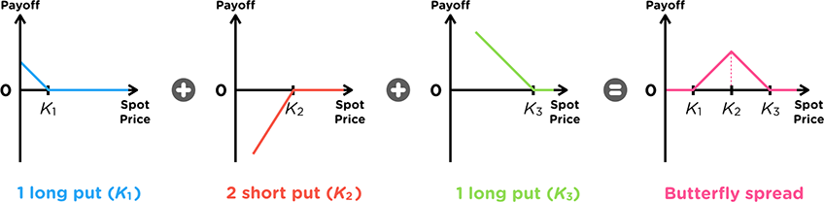

## 

## Asymmetric Butterflies

* The spread still reflects the investors belief that the prices will not change much, but also accounts for an **investors opinion if they are more bearish or bullish** on the stock
  + 
  + 

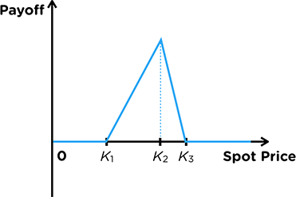

Consider the range of strike prices:







Number of options to buy:







* The **spread is the number of options** to buy for the option with the strike that was not used

# Ratio Spread

* 
* We can think of Ratio Spreads as buying a Call/Put, but **financing the purchase through selling Calls/Puts** of a different strike
* This **lowers the cost of the position** in **exchange for more risk** if the price increases too much
* 

## Buying Ratio Spreads

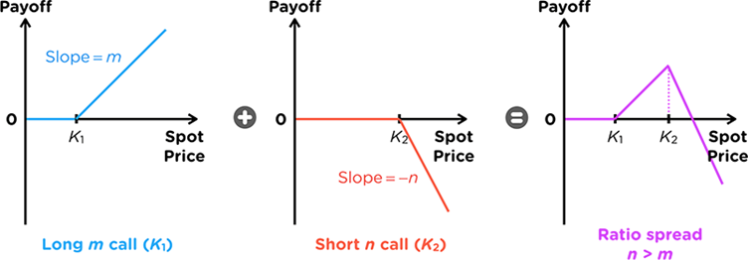

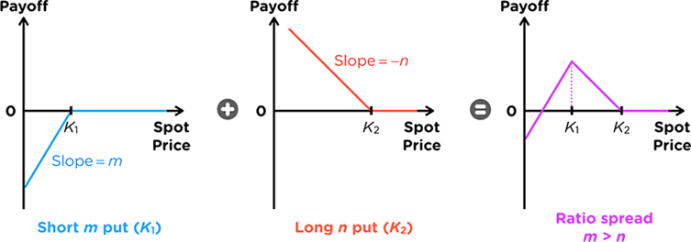

# Properties to Remember Spreads

|  |  |  |  |  |
| --- | --- | --- | --- | --- |
| **Spread** | **Type** | **Strike** | **Position** | **Number** |
| **Bull Spread** | Calls **OR**  puts | Higher Strike  Lower Strike | Short Higher  Long Lower | One each |
| **Bear Spread** | Calls **OR**  puts | Higher Strike  Lower Strike | Long Higher  Short Lower | One each |
| **Box Spread** | Bull **&**  Bear | Same  Range | Call Bull  Put Bear | One each |
| **Butterfly Spread** | Bull **&**  Bear | Higher range  Lower range  **Symmetrical** | Bull Lower Range  Bear Higher Range | One each |
| **Asymmetric Butterfly** | Bull **&**  Bear | Higher range  Lower range  **Asymmetrical** | Bull Short Higher Range  Bear Long Higher Range | Formula |
| **Ratio Spread** | Calls **OR**  puts | Higher Strike  Lower Strike | No Relationship | No Relationship |

Unless otherwise stated, all spreads have the **same maturity**

**Combinations (Long only)**

# Collar

* Collars are typically not bought on their own but rather along with a stock (**Collared Stock**)
* In this light, notice that a collar is a **Covered Call with a Put Option** to cover the downside risk

S<KI 
Long put Kl 
Short call K2 
Total Cashflow 
K2<S 
= Kz—ST 

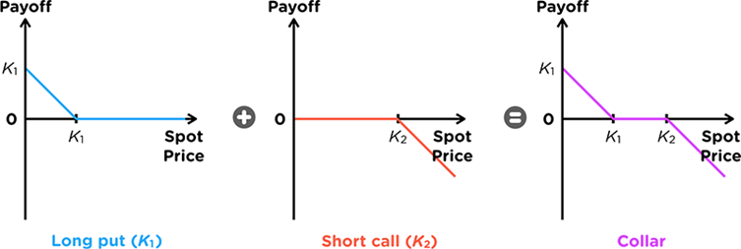

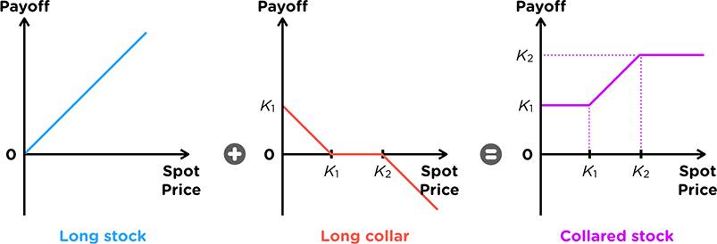

## Zero Cost Collar

* The most intuitive method to create a Zero Cost Collar would be to set the strike prices for BOTH options to be equal
* This allows for the use of Put Call Parity - through this, the strike price that sets the initial cost to 0 is a strike price that is equal to the **Forward Price**
* Since the strikes are now equal, the width of the collar is now gone, which is also known as a **Zero Width Collar**









However, there is another method to create a Zero Cost Collar:

* Set the Strike of the Put to be **lower than the Forward Price**
* It is possible to then find a Strike for the call that is higher than the Forward Price with premium equal to that of the put, resulting in a zero-cost collar
* Thus, zero cost collars need NOT necessarily be zero-width

# Straddle

* They are used when investors believe the prices will change by a **large magnitude** in EITHER direction
* Straddles can be formed by buying a Put and Call at the **same Strike Price**

Long put 
Long Call 
Total Cashflow 

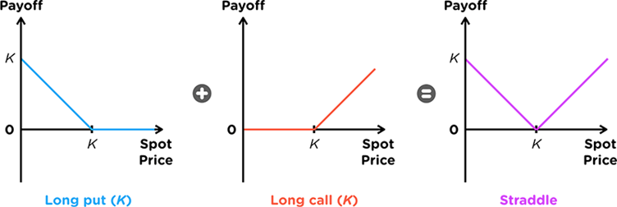

# Strangle

* 
* 
  + Since the Put has a lower strike price, the **premium paid is lower**
  + Since the Call has a higher strike price, the **premium paid is lower**

S<KI 
K2<S 
Long Put 
Long Call K2 
Total Cashflow 
0 

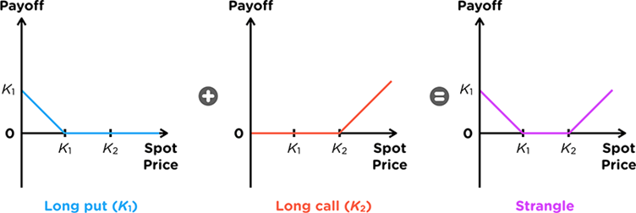

# Properties to Remember Combinations

|  |  |  |  |  |
| --- | --- | --- | --- | --- |
| **Spread** | **Type** | **Strike** | **Position** | **Number** |
| **Collar** | Calls &  Puts | Higher Strike  Lower Strike | Short Higher strike **Call**  Long Lower strike Put | One each |
| **Straddle** | Calls &  Puts | Same Strike | Long both | One each |
| **Strangle** | Calls &  Puts | Higher Strike  Lower Strike | Long Both | One each |

Unless otherwise stated, all spreads have the **same maturity**